Mod 7 R and Discrete Probability Distributions
Myles Sartor

Use R functions for probability distributions in this assignment. For example, if you are finding probabilities for the binomial, use the dbinom, pbinom, etc. Round all probabilities to 4 Decimal Places.

Use for Problems 1-3: According to American Airlines, its Flight 215 from Orlando to Los Angeles is on time 85% of the time. Suppose 8 flights are randomly selected and the number of on-time flights is recorded. Use R to create the Binomial distribution function.

- What is the probability that exactly 5 flights are on-time out of the eight randomly selected flights? (Answer to 4 decimal places) (1pt)
Code: (Insert code below)
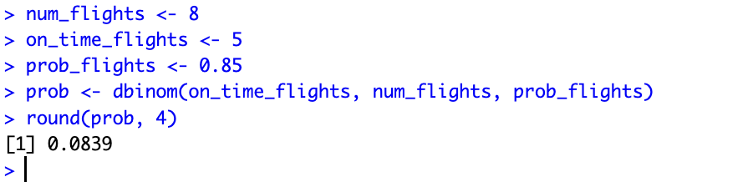
Answer below:
0.0839 (8.4 %)

- What is the probability that more than 4 flights are on-time out of the eight randomly selected flights? (Answer to 4 decimal places) (1pt)
Code: (Insert code below)
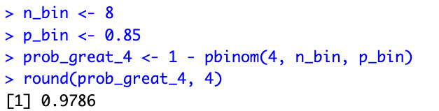
Answer below:
0.9786 (97.86 %)

- What is the probability that between 3 and 7 flights are on-time out of the eight randomly selected flights, inclusive (P(3≤X≤7)? (Answer to 4 decimal places) (1pt)
Code: (Insert code below)
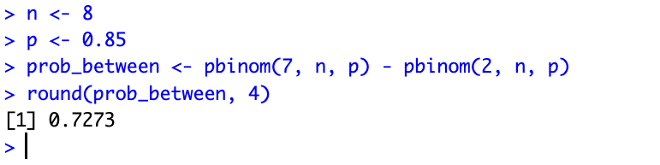
Answer below:
0.7273 (72.73 %)

Use for Problems 4-6: A large supermarket stocks both national brands of coffee and its own house brand. Consider a single randomly selected customer purchasing coffee and let success = the customer purchases a national brand. Assume that p = 0.75 and that customers make coffee purchase decisions independently of one another. Use R to calculate the probabilities.

- Let X = number of house brand coffee purchasers before a certain number purchase a national brand. (Negative Binomial)
  - Find the probability that 7 coffee purchasers will buy house brand coffee before 3 will purchase a national brand. (Answer to 4 decimal places) (1pt)
Insert your code here:
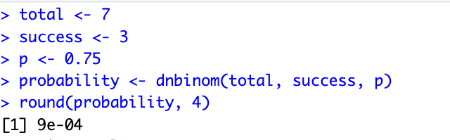
Answer:
0.0009 (0.09 %)

  - Find the probability that more than 2 coffee purchasers will buy house brand coffee before 2 will purchase a national brand. (Answer to 4 decimal places) (2pt)
Insert your code here:
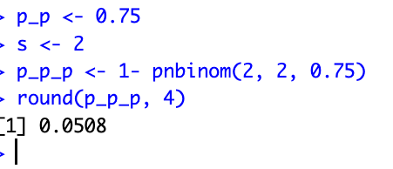

Answer: 0.0508 (5.08 %)

- Let X = the number of house brand coffee purchasers before one purchases a national brand. (Geometric, special case of the negative binomial)
  - Find the probability that 5 coffee purchasers will buy house brand coffee before one will purchase a national brand. (Answer to 4 decimal places) (1pt)
Insert your code here:
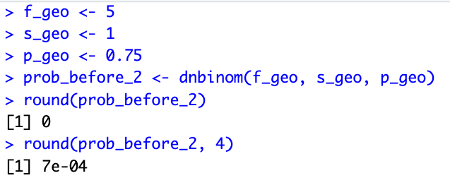
Answer:
0.0007 (0.07 %)

  - Find the probability that at least 2 coffee purchasers will buy house brand coffee before one will purchase a national brand. (Answer to 4 decimal places) (2pt)
Insert your code here:
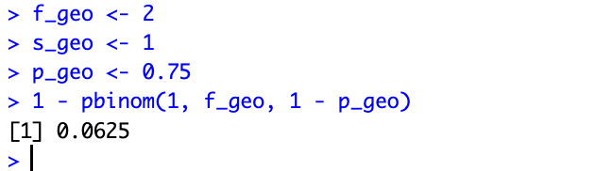
Answer:
0.0625 (6.25 %)
- If we are looking at 50 coffee purchasers and know that 40 purchased a national brand. If we want to find the probability a certain number of coffee purchasers will buy a national brand from a sample of 10 of the coffee purchasers, we are in the hypergeometric distribution.
  - Find the probability that exactly 5 of the 10 sampled coffee drinkers will purchase a national brand. (Answer to 4 decimal places) (1pt)
Insert your code here:
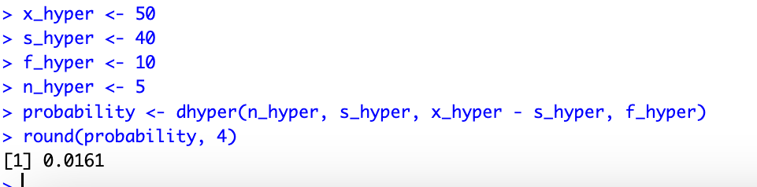
Answer: 0.0161 (1.61 %)

